**Android Defects**

**Problem:** Set name was getting set to null

Was setting the name incorrectly. Name is null because it is not set.

**public** **void** setName(String name) {

name=this.name;

}

**Solution:**

Swap the assign of this.name name.

This way the instance variable name is set by the parameter that is passed in.

“**this**” refers to this current object.

**public** **void** setName(String name) {

this.name=name;

}

**Problem:** Spinner is null because the view is not initialize with the spinner;

Spinner needs to get the view that is inflated from the fragment.

**public** View onCreateView(LayoutInflater inflater, ViewGroup container,

Bundle savedInstanceState) {

View view = inflater.inflate(R.layout.*fragment_rsslist_overview*,

container, **false**);

Spinner listspinner = (Spinner)getView().findViewById(R.id.*spinner1*);

spinner1 = (AdapterView<ListAdapter>) view.findViewById(R.id.*spinner1*);

ArrayList<String> list = **new** ArrayList<String>()

list.add("Sample List");

list.add("New List");

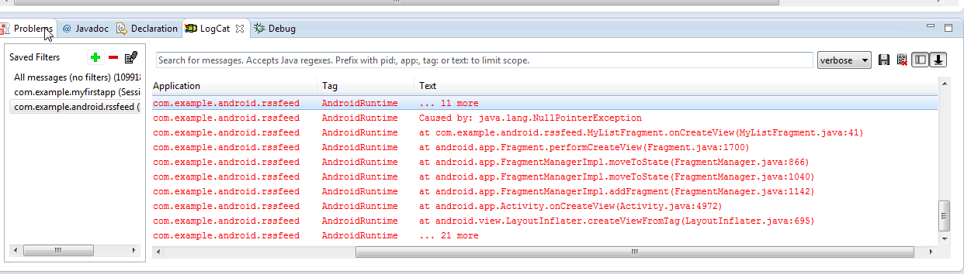

Solution: Get the view that was inflated from the fragment

View view = inflater.inflate(R.layout.*fragment_rsslist_overview*,

container, **false**);

Spinner listspinner = (Spinner)view.findViewById(R.id.*spinner1*);

Nullpointer exception

**Problem:** Abort at line **“listspinner.setOnItemSelectedListener(new CustomOnItemSelectedListener(context));”**

Listspinner is null in method because the listspinner is not set unless you pass this variable as a parameter.

**Solution:** Pass Spinner as parameter.

AdapterView<ListAdapter> spinner1;

Spinner listspinner;

Context context;

@SuppressWarnings("unchecked")

@Override

**public** View onCreateView(LayoutInflater inflater, ViewGroup container,

Bundle savedInstanceState) {

View view = inflater.inflate(R.layout.*fragment_rsslist_overview*,

container, **false**);

Spinner listspinner = (Spinner)view.findViewById(R.id.*spinner1*);

spinner1 = (AdapterView<ListAdapter>) view.findViewById(R.id.*spinner1*);

ArrayList<String> list = **new** ArrayList<String>();

list.add("Sample List");

list.add("New List");

//listener.onRssItemSelected(position);

ArrayAdapter<String> dataAdapter = **new** ArrayAdapter<String>(getActivity(),

android.R.layout.*simple_list_item_1*, list);

dataAdapter.setDropDownViewResource

(android.R.layout.*simple_spinner_dropdown_item*);

listspinner.setAdapter(dataAdapter);

// Spinner item selection Listener

addListenerOnSpinnerItemSelection();

**return** view;

}

// Add spinner data

**public** **void** addListenerOnSpinnerItemSelection(){

listspinner.setOnItemSelectedListener(**new** CustomOnItemSelectedListener(context));

listspinner.setOnTouchListener(spinnerOnTouch);

listspinner.setOnKeyListener(*spinnerOnKey*);

}

**Solution:** Pass Spinner as parameter.

AdapterView<ListAdapter> spinner1;

Spinner listspinner;

Context context;

@SuppressWarnings("unchecked")

@Override

**public** View onCreateView(LayoutInflater inflater, ViewGroup container,

Bundle savedInstanceState) {

View view = inflater.inflate(R.layout.*fragment_rsslist_overview*,

container, **false**);

Spinner listspinner = (Spinner)view.findViewById(R.id.*spinner1*);

spinner1 = (AdapterView<ListAdapter>) view.findViewById(R.id.*spinner1*);

ArrayList<String> list = **new** ArrayList<String>();

list.add("Sample List");

list.add("New List");

//listener.onRssItemSelected(position);

ArrayAdapter<String> dataAdapter = **new** ArrayAdapter<String>(getActivity(),

android.R.layout.*simple_list_item_1*, list);

dataAdapter.setDropDownViewResource

(android.R.layout.*simple_spinner_dropdown_item*);

listspinner.setAdapter(dataAdapter);

// Spinner item selection Listener

addListenerOnSpinnerItemSelection(listspinner);

**return** view;

}

// Add spinner data

**public** **void** addListenerOnSpinnerItemSelection(Spinner listspinner){

listspinner.setOnItemSelectedListener(**new** CustomOnItemSelectedListener(context));

listspinner.setOnTouchListener(spinnerOnTouch);

listspinner.setOnKeyListener(*spinnerOnKey*);

}

**Solution:**

Pass current data adapter as a parameter when dataadapter is created.

Pass dataadapter to customer itemlistener class. In the constructor, The custom itemlistener can initialize its own dataadapter and assigned the data adapter that is passed from parameter.

The data adapter current data adapter can be retrieve and titles can be added to the adapter.

**public** **class** MyListFragment **extends** ListFragment {

**public** View onCreateView(LayoutInflater inflater, ViewGroup container,

Bundle savedInstanceState) {

…

//listener.onRssItemSelected(position);

ArrayAdapter<String> dataAdapter = **new** ArrayAdapter<String>(getActivity(),

android.R.layout.*simple_list_item_1*, list);

dataAdapter.setDropDownViewResource

(android.R.layout.*simple_spinner_dropdown_item*);

listspinner.setAdapter(dataAdapter);

// Spinner item selection Listener

addListenerOnSpinnerItemSelection(listspinner,dataAdapter);

**return** view;

}

// Add spinner data

**public** **void** addListenerOnSpinnerItemSelection(Spinner listspinner,ArrayAdapter<String> dataAdapter){

listspinner.setOnItemSelectedListener(**new** CustomOnItemSelectedListener(context,listspinner,dataAdapter));

listspinner.setOnTouchListener(spinnerOnTouch);

listspinner.setOnKeyListener(*spinnerOnKey*);

}

**public** **class** CustomOnItemSelectedListener **extends** MyListFragment **implements** OnItemSelectedListener {

ArrayAdapter<String> spinnerAdapter;

**private** OnItemSelectedListener listener;

**public** CustomOnItemSelectedListener(Context context,Spinner spinnertitles,ArrayAdapter<String> spinnerAdapter) {

**this**.spinnertitles=spinnertitles;

**this**.context=context;

**this**.spinnerAdapter=spinnerAdapter;

}

**public** **void** onItemSelected(AdapterView<?> parent, View view, **int** pos,

**long** id) {

…

spinnerAdapter.add(input.getText().toString());

spinnerAdapter.notifyDataSetChanged();

spinnertitles.setAdapter(spinnerAdapter);

…

**Problem:** Item inserted twice in arraylist of strings twice. Displays is listview twice in Android UI.

**else** **if**(menuItemName.equals("Add") && listselectedid==index)

{

…

ArrayList<String> lst3 = **new** ArrayList<String>();

lst3.addAll(Arrays.*asList*(RssfeedActivity.*values*));

**final** ArrayAdapter<String> adapter3 = **new** ArrayAdapter<String>(RssfeedActivity.**this**,

android.R.layout.*simple_list_item_1*, lst3);

list.add(index+1,listinput)

adapter3.insert(listinput,index+1);

adapter3.notifyDataSetChanged();

detailfragment.setListAdapter(adapter3);

RssfeedActivity.*values*=AddtoArray(lst3,listinput,index);

AddtoArrayMethod

**public** String[] AddtoArray(ArrayList<String> lst1, String currentitem,**int** index)

{

lst1.add(index,currentitem);

String[] finalarray = **new** String[lst1.size()];

finalarray = lst1.toArray(finalarray);

**return** finalarray;

}

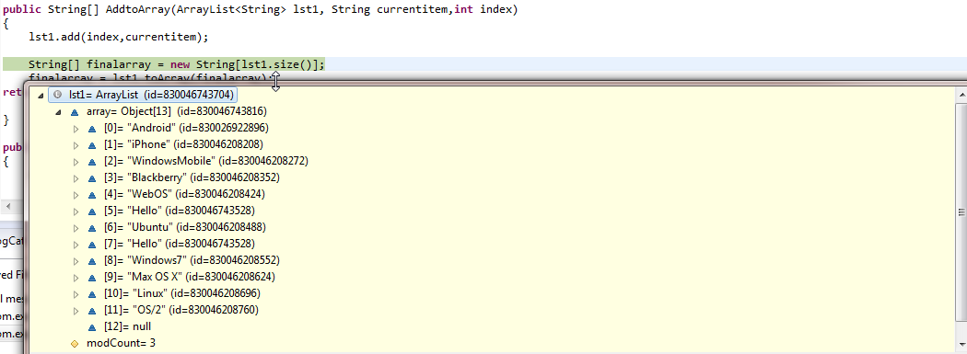

Item were inserted into the arraylist twice.

Solution

From further investigation, the Array adapter actually adds to the actual arraylist.

To fix this problem, I commented the line where the programs adds the current item to the arraylist.

**else** **if**(menuItemName.equals("Add") && listselectedid==index)

{

…

ArrayList<String> lst3 = **new** ArrayList<String>();

lst3.addAll(Arrays.*asList*(RssfeedActivity.*values*));

//list.add(index+1,listinput)

**final** ArrayAdapter<String> adapter3 = **new** ArrayAdapter<String>(RssfeedActivity.**this**,

android.R.layout.*simple_list_item_1*, lst3);

adapter3.insert(listinput,index+1);

adapter3.notifyDataSetChanged();

detailfragment.setListAdapter(adapter3);

RssfeedActivity.*values*=AddtoArray(lst3,listinput,index);

Problem: Peformance problem when there were a lot of list for the spinner or a lot of items in the list. The application would run very slowly.

@Override

**public** View getView(**int** position, View convertView, ViewGroup parent) {

// **TODO** Auto-generated method stub

LayoutInflater inflater = ((Activity)context).getLayoutInflater();

convertView = inflater.inflate(R.layout.*fragment_rssitem_detail*, parent, **false**);

TextView name = (TextView) convertView.findViewById(R.id.*detailsText*);

CheckBox cb = (CheckBox) convertView.findViewById(R.id.*checkBox1*);

checkboxlist.add(cb);

Solution:

Create Static TextView Holder class and assign text view when current view is null. This is so the code doesn’t call findViewById method as much. Calling this method a lot can cause performance issues.

**static** **class** ViewHolder {

TextView text;

CheckBox checkbox;

}

@Override

**public** View getView(**int** position, View convertView, ViewGroup parent) {

// **TODO** Auto-generated method stub

LayoutInflater inflater = ((Activity)context).getLayoutInflater();

ViewHolder holder = **new** ViewHolder();

**if**(convertView==**null**){

convertView = inflater.inflate(R.layout.*fragment_rssitem_detail*, parent, **false**);

holder.text = (TextView) convertView.findViewById(R.id.*detailsText*);

holder.checkbox = (CheckBox) convertView.findViewById(R.id.*checkBox1*);

convertView.setTag(holder);

}

**else** {

holder = (ViewHolder) convertView.getTag();

}

CheckBox cb = holder.checkbox;

TextView text =holder.text;